Lab-3
Abdul Samian
023-22-0202
CA and Assembly

Question no 1: Write an assembly language program that displays your name 10 times (using a loop).
Solution:
.model small
.stack 100h
.data
myname db "Abdul Samian$"
.code
main proc
mov ax, @data
mov ds, ax

mov cx, 10

lea dx, myname

myloop:
mov ah, 9
int 21h

mov ah, 2
mov dl, 10
int 21h
mov dl, 13
int 21h

lea dx, myname

loop myloop

mov ah, 4ch
int 21h

main endp
end main
Output
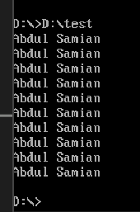

Question no 2: Write an assembly language program that displays numbers from 0 to 9, as shown below:
Solution:

.model small
.stack 100h

.data

.code
main proc
mov cx, 10
mov bl, 0

mov ah, 2
myloop:
mov dl, bl
inc bl

add dl, 48
int 21h
loop myloop

mov ah, 4ch
int 21h
main endp
end main

Output
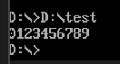

Question no 3: Write an assembly language program that asks the user to input a number as an ending range. Then, the program should display numbers from 1 to that ending range (entered by the user), as shown below
Solution:
.model small
.stack 100h

.data
prompt1 db "Enter ending range number: $"
prompt2 db 'The numbers upto entered range are: $'
.code
main proc
mov ax, @data
mov ds, ax

; Print the first prompt
mov ah, 9
lea dx, prompt1
int 21h

; Take input
mov ah, 1
int 21h

; Store it in ll register
mov cl, al
sub cl, 48

; Move to the next line
mov ah, 2
mov dl, 10
int 21h
mov dl, 13
int 21h

; Print the second prompt
mov ah, 9
lea dx, prompt2
int 21h

; Print the output through loop
mov bl, 1
mov ah, 2
myloop:
mov dl, bl
add dl, 48
int 21h
inc bl
loop myloop

mov ah, 4ch
int 21h
main endp
end main

Output
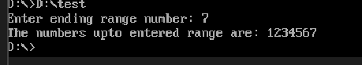

Question no 4: Write an assembly language program to display English alphabet (in upper case A - Z) on the screen (using a loop), as shown below:
Solution:
.model small
.stack 100h

.data
.code
main proc
mov ah, 2
mov dl, 65
mov cx, 26

myloop:
int 21h
inc dl
loop myloop
mov ah, 4ch
int 21h
main endp
end main

Output
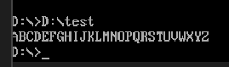

Question no 5: Write an assembly language program to display English alphabet (in small cases a - z) on the screen (using a loop), as shown below:

Solution:
.model small
.stack 100h

.data
.code
main proc
mov ah, 2
mov dl, 'a'
mov cx, 26
myloop:
int 21h
inc dl
loop myloop

mov ah, 4ch
int 21h
main endp

end main

Output
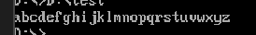

Question no 6: Combine the previous two programs to display capital alphabets on one line and small alphabets on the second line, as shown below
Solution:
.model small
.stack 100h

.data
prompt1 db "English alphabets in uppercase: $"
prompt2 db 10, 13, "English alphabets in lowercase: $"
.code
main proc
mov ax, @data
mov ds, ax

; Print prompt 1
mov ah, 9
lea dx, prompt1
int 21h

; Print capitals
mov cx, 26
mov ah, 2
mov dl, 'A'
myloop:
int 21h
inc dl
loop myloop

; Print prompt 2
mov ah, 9
lea dx, prompt2
int 21h

; Print smaller alphabets
mov cx, 26
mov ah, 2
mov dl, 'a'
myloop2:
int 21h
inc dl
loop myloop2

mov ah, 4ch
int 21h
main endp

end main

Solution
